Advanced Placement Biology Syllabus
Instructor: Ms. Lauren Smith
Email: lauren.smith@nn.k12.va.us
Website: www.mssmithsbiology.weebly.com
Textbook: Hillis, Sadava, Heller, Price. Principles of Life 1st Edition

Required Materials for Class:
- 1 Composition notebook. This notebook will be used as a lab notebook.
- 1 other notebook (spiral or composition) for Do Now’s and Notes.
- Highlighters, Pens, and Pencils.

Supplemental Materials:
- Internet Access- I have a classroom website that we will extensively use, as well as other online resources.
- Planner- Staying organized and managing your time wisely will be key to being successful in this course.
- AP Biology Study Book- is recommended, especially if you haven’t taken High School Biology. However, you have to make sure it is a book that is published in 2014 or earlier

Classroom and Course Expectations:

AP Biology is probably the best class you will take in your entire high school career, but there is a whole lot of work involved! College Board has redesigned the AP Biology curriculum to focus on enduring and conceptual understandings that the content will support. We will use an inquiry based approach to help you gain an understanding of essential concepts instead of just memorizing the facts. We will use the curriculum set forth by the College Board.
AP Biology is a college level course! This means you will have to work incredibly hard to perform well, attend class every day, and you will need good time management skills. A college level Biology Course usually consists of a lecture section three times per week and a lab component one time per week. With a large portion of work and studying being completed outside of the class room. We will try and mimic this structure as much as possible with 60% being lecture or other activities and 40% labs.
Part of this class is to get you prepared to take the AP Biology Exam on Monday, May 8th, 2017. Your score on the exam could earn you up to FOUR early college credits, so your hard work could really pay off!
YOU are expected to come to class prepared every day and be responsible for your own property, behavior, and learning! Make sure that you complete all labs and assignments on time! Arrive to class before the bell rings! If you are walking in the door as the bell is ringing you are LATE! Make sure you read the board and calendar every day, I will list the assignments/ homework there along with their due dates. Make sure you write these dates down. You may bring water to class only, and only if it is in a sealable container, like a water bottle. Make sure you read and follow the safety contract; lab safety is one of my top priorities.
Failure to comply with these expectations will result in consequences including but not limited to…
- Warnings and Redirections
- Teacher/Student Conferences
- Contact with Parents
- Removal from classroom or lab activity
- Disciplinary Referral to the appropriate administrator.

AP Biology Big Ideas:
There are four Big Ideas that the AP curriculum is designed around. Many units will touch on more than one Big Idea!
- Big Idea #1: The process of evolution drives the diversity and unity of life.
- Big Idea #2: Biological systems utilize energy and molecular building blocks to grow, reproduce, and maintain homeostasis.
- Big Idea #3: Living systems retrieve, transmit and respond to information essential to life processes.
- Big Idea #4: Biological systems interact, and these interactions possess complex properties.

Cell Phone Policy:
Cell phones are expected to remain out of sight and use UNLESS we are using them for a classroom activity. We are a Bring Your Own Device school, meaning that your device must have a sticker in order for you to use it. If you are using your phone inappropriately at all it will be confiscated. However, I hope to be using your cell phone in class frequently, so do not make any other teachers take it from you either!

Extra Help:
If you need additional help for any reason, you may stay after school once you have made an appointment with me. I usually stay after school on Wednesdays, but I am available other days if you ask. Students will need to have asked me in advance or I will not let you stay with me, and you must provide your own transportation home.

Absences or Missed Class:
After a student is absent, they will pick up their “While You Were Out” form that details the missed work and includes missed worksheets/handouts. It is the student’s responsibility to collect this work and see that it is handed in. It is also recommended that the student check in with the teacher to ask any questions about the missed work and make sure that there are no other missing assignments. Students will automatically receive a zero for missing work! All missing or late work must be turned in by that Unit’s test day, after that unit has been tested on, no late work will be accepted. If you miss a test or quiz day you will have 5 class periods to make it up, otherwise it will be a zero in the grade book. Accommodations will be made on an individual basis.

Course Planners:
Still under construction… But once completed I will make sure to update this section.

Grading Policy:
There will be a variety of ways students will be evaluated in this course: Tests, Labs, Quizzes, Classwork, and Homework. All tests will have two main components: a multiple choice section and a free response section to model after the AP Biology Exam. Labs will be completed in a Laboratory notebook that will comprise most of the Lab grade component. We will follow the Newport News Public Schools standard 10 point grading scale.
- A=100-90
- B=89-80
- C=79-70
- D=69-60
- F=59-0
Each semester will be using the following categories and weights:
1st Semester:
- Tests= 40%
- Labs= 30%
- Quizzes/ Classwork/ Homework= 15%
- Science Fair Project= 15%
2nd Semester:
- Tests= 40%
- Labs= 40%
- Quizzes/Classwork/ Homework= 20%

AP Biology Exam Structure:
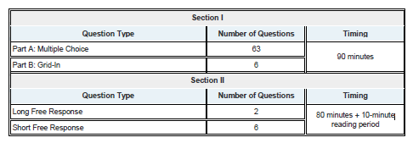

AP Biology Credit:
The following is a sampling list of a few Virginia Colleges and Universities that will give you credit for Biology depending on your AP Biology Exam Score!
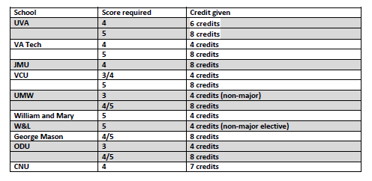

This syllabus serves as a living document that is subject to change! Make sure you check the classroom website often and I will do my best to notify you of changes!

