AP Biology: Things to Know for Unit 4 Test:
Pages Chapter 6: 113-121
- Light Dependent Reactions
  - Where they occur and Chloroplast Structure
    - Thylakoids (Chloroplast Coloring Activity)
  - What happens in Photosystem II
    - Needed: Water and Light
    - Produced: Oxygen and Proton Gradient that Drives ATP Synthase
  - What happens in Photosystem I
    - Needed: Light
    - Produced: NADPH
- Light Independent Reactions
  - The Calvin Cycle
    - Three major phases (fixation, reduction, and regeneration)
    - Needed: Carbon Dioxide, NADPH, and ATP
  - Where/When they occur
    - In Stroma for C3 plants
    - In Bundle Sheath cells for C4 plants
    - At night in CAM Plants
  - Overall Product: Sugars or Starches (long term storage)
- Major Differences between C3, C4, and CAM Plants
  - Where fixation happens and when
  - The inefficiency of Rubisco (as in oxygen competes with carbon dioxide)
- Chemical Formula for Photosynthesis
  - 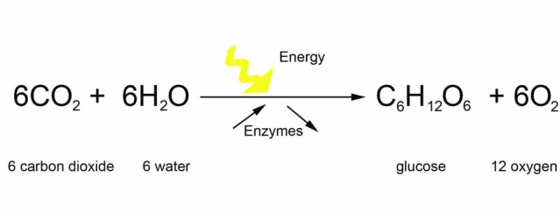
- What can affect photosynthesis rates
  - Light intensity
  - Amount of CO2 available
  - Amount of Water available
- Cyclic vs. Noncyclic Photophosphorylation
- Other things to remember:
  - Temperature effects on reactions
  - Protons have a low pH, and pH trends in general
  - Differences between ATP and GTP

